Station 2: Writing about your languages



Name: ____________________

Warm up

Can you remember making a language portrait last year? Here is Ms Smith’s:

This is Ms Wiener’s language portrait. German and English are in her heart because these are her best languages and the ones she speaks with her family.

She also learned a bit of Gaelic in Ireland, so that is also close to her heart.

French is in her foot because she learned that at school but she has forgotten a lot, just like Latin.

Ms Wiener’s students are very multilingual, and their languages are part of her life too, as she hears them every day at school and in her community.

**Ms Wiener loves languages!**

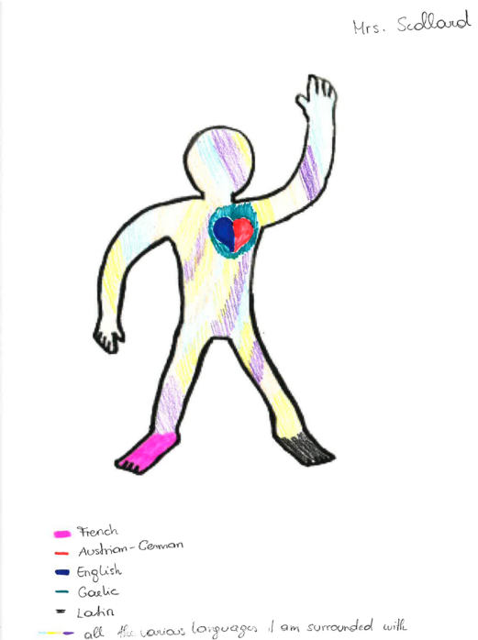

Now it’s your turn to write a text about your language portrait!

Pre-writing

Make some notes with your ideas. Use whatever languages you want.

You might like to write about:

What languages do you speak?

What languages do you hear in your environment?

What languages are you interested in?

Where did you draw your languages?

What colors did you use and why?

Did you like this exercise? Why or why not? Etc.

**Notes about what I want to write:**

____________________________________________________________________________________________________________________________________________________________________________________________________________________________________________________________________________________________________________________________________________________

Writing

Now formulate 4-6 sentences about your language portrait in English. You will probably need the *present simple tense*.

Here are some *phrases* you could use:

* I drew German in the arm because…
* I chose black for my head because…
* I painted my foot green because it is my favorite color and my favorite language.
* I enjoyed this exercise because …
* I did not enjoy this exercise because …

|  |
| --- |
| My language portrait:  _________________________________________________________________________________________________________________________________________________________________________________________________________________________________________________________________________________________________________________________________________________________________________________________________________________________________________________________________________________________________________________________________________________________________________________________________________________________________________________________________________________________________________________________________________________________________________________________________________________________________________________________________________________________________________________________________________________________________________________________________________________________________________________________________________________________________________________________________________________________________________________________________________________________________________________________________________________________ |

Finished the exercise:

Feedback from teacher: ____________________________________________________

________________________________________________________________________