Worksheet: Clocks in Vienna

Where might these clocks be? What time is it on each of the clock?

Ein Bild, das Gebäude, Himmel, Uhr, draußen enthält.
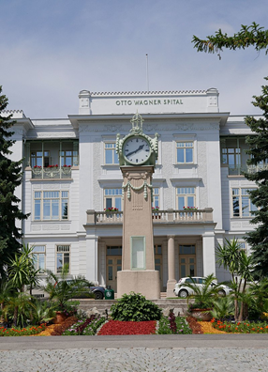

Source: <https://commons.wikimedia.org/wiki/File:Otto-Wagner-Spital_Baumgartner_H%C3%B6he_11.jpg>

___________________________________

___________________________________

**Homework:**

Is there a clock in your house? On the way to school? Take a photo of a clock that you notice. Bring the photo to our next class.

Source: <https://commons.wikimedia.org/wiki/File:Wien_Praterstern_July_2008_(34).jpg>

___________________________________

__________________________________