**Work Package:**

**Teaching the Time in the English Language Classroom**

**Level:** A2

**Topic:**  Time, daily routines

**Competence area:** Consolidate and reinforce proficiency in telling the time in all of students’ languages, express and comprehend time-related concepts in English, ask and respond to time-related questions, describe daily routines; use time expressions

**CEFR Descriptor:** Can ask about leisure time and life at school, and can set a time

**Unit Suggestions:** *More!* 1: Unit 11; *Prime Time* 1 (2017/2019): Unit 4; *English Step by Step* (2023): Unit 12; *Green Line* 1 (2021): Unit 2; etc.

**Contents:** Teacher’s Notes, Lesson Sequence Ideas, Worksheets 1-5, PPP

Many English textbooks introduce telling time through phrases like "quarter past" and "half past," but the challenge extends beyond vocabulary—it’s about truly understanding and expressing the concept. For many students, telling time can be tricky, and the challenge grows when learning a new language. Some students might even question the relevance of analog clocks in today’s digital world, but encouraging them to notice clocks in their environment helps them recognize that telling the time is an additional, valuable resource.

Using students' full language repertoire as a resource deepens their conceptual understanding of time in English. By connecting their knowledge across languages, teachers can assess existing understanding and enhance comprehension. When students draw on their languages to understand and express time, it strengthens their overall learning. Incorporating students' home languages, alongside English, helps them see the similarities and differences, enriching their grasp of the concept.

Lastly, students need time and regular review to master telling time. A variety of worksheets, games, and digital resources ensures ample practice, keeping students engaged. Repetition and opportunities for reflection are essential for solidifying their understanding. By investing time in teaching this topic, we can help students confidently express time in all of their languages, including English and develop their conceptual understanding of time.

Teachers can use the resources provided in any order, adapting them to best suit their students’ needs. Ideas for both weaker and more advanced students are included.

For more on this topic, see

Erling, E.J., Yildiz, G. & Weidl, M. (2023) Teaching the Time Using Translanguaging Pedagogies in Austrian ELT: A Transformational Action Research Collaboration. In Müzeyyen Nazlı Güngör (Ed.), *Action Research in English Language Teaching: Voices from Diverse Contexts* (Word of ELT). Black Swan Publishing. <https://online.pubhtml5.com/jsnr/vvkh/index.html>

**Verortung im BMBWF Kompetenzraster**

Die Lernaufgabe lässt sich im Kompetenzraster folgendermaßen verorten:

|  |
| --- |
| **Kompetenzbereich Sprechen** (miteinander kommunizieren)**:**  Die SchülerInnen können...   * in verschiedenen Situationen auf einfache Art kommunizieren (z.B.: über tägliche Routinen sprechen) * einfache Wörter und Phrasen zu erarbeiteten Themen und Inhalten wiedergebe |
| **Kompetenzbereich Schreiben** (nach Vorbild schreiben)**:**  Die SchülerInnen können Wörter und Phrasen nach Vorbild schreiben. |
| **Kompetenzbereich Lesen** (Vorlesen und verstehen)**:**  Die SchülerInnen können Wörter und Phrasen wiedererkennen und vorlesen. |
| **Kompetenzbereich Hören** (Detailverstehen)**:**  Die SchülerInnen können kurze Fragen und Anweisungen verstehen. |
| **Fachübergreifende Themen:**   * Verständnis von Uhrzeiten, Zeitspannen, und der Einteilung des Tages (z. B. volle Stunden, Viertelstunden, halbe Stunden) (Mathematik). * Konzeptuelles Verständnis von Zeit, Tagesablauf, Jahreszeiten, Kalender (Mathematik). * Nutzung digitaler Uhren, Kalender-Apps oder Timer zur Zeitmessung (Digitale Grundbildung). * Zeitmessung in Spielen oder sportlichen Aktivitäten (z. B. Stoppuhr nutzen, Dauer von Übungen angeben) (Bewegung und Sport). |
| **Übergreifende Kompetenzen:**  Die SchülerInnen können einfache Strategien zur Unterstützung ihres Sprachenlernens anwenden (z.B. visuelle Hilfsmittel wie Uhren oder Tagespläne nutzen, Muster in Zeitangaben erkennen, Gemeinsamkeiten mit anderen bekannten Sprachen entdecken. |

# **Contents**

This Work Package consists of:

* **Teacher’s Notes**, which offer a brief overview of the contents
* **Lesson Sequence Ideas**, which are sequences that can be adapted into your lesson plans.
* A **Power Point Presentation** (PPP), which can be adapted used directly in the classroom.
* **Worksheets 1-5**, which can be adapted and used directly in the classroom.

**Teacher’s Notes**

## **Worksheet 1: Clocks in Vienna [or Your Town]: Noticing Time in Our Daily Lives**

This worksheet activates students’ prior knowledge about clocks and telling the time and shows the relevance of being able to read an analogue clock in daily life. It raises awareness of the societal and historical significance of telling the time.

The first part of the worksheet can be given as homework before the unit and used as an intro to the first lesson. This can help you get a sense of your students’ needs. The second part can be done in class, in groups or pairs.

Feel free to change the images of clocks used to suit your context. You might also want to change the names and languages to suit your classroom environment.

## **Worksheet 2: An Empty Clock: Eliciting Time Vocabulary Across Languages**

**Reviewing the Basics:** Start by checking how well students can read an analogue clock using the languages they are familiar with. Some students may need to review the basics of telling time. To find out what students already know, ask:

* How do you say the time in different languages?
* Do you know the words for hours, minutes, and parts of the clock in the languages you know?

**Filling in the Clock:** Have students fill in the numbers on the empty clock. This will help them get comfortable with the shape and layout of the clock. You can also project the empty clock on the board and ask your students to tell you words and phrases related to time, such as:

* Numbers (1–12)
* Parts of a clock (the hour and minute hand)
* Phrases like "half past three," "quarter to," etc., e.g. halb vier, Saat üç buçuk or üç yarım (Turkish); Polovica četiri or polovica tri (BKS)

Write them on the board and let students copy them into their notebooks if they wish.

Discuss any similarities or differences with English time expressions.

## **PPP Slides: In-class Tasks**

**Activity: The Simpson Family**  
In this activity, students use the provided words from the PPP slides to form sentences about what each member of the Simpson family does at a certain time. They need to conjugate the verb and use the correct time. This helps students practice both telling time and speaking in full sentences, reviewing the present simple tense.

**Task Question:**  
What do the Simpsons do every day?

Students should respond using the present tense, such as "Homer eats a donut at one forty-five".

This activity provides a scaffolded environment for students to practice speaking about time, preparing them for the next task, where they use their language skills more independently to talk about Zeynab’s Schedule.

## **Worksheet 3: Zeynab’s Schedule: Info Gap Activity**

This activity can be used as a fun, interactive info-gap activity to get students talking and listening about time in the classroom. The main focus is on speaking and listening, so students should be encouraged to actively engage with each other and pay attention to the answers.

The activity is similar to the game “Battleship.” In this case, Student A and Student B each have a copy of Zeynab’s Schedule (A and B), with the **activities** missing (but the **times** already filled in). The goal is for students to ask each other questions to figure out the missing activities at each time slot.

Example:

*Student A:* Does Zeynab usually read at 9:30 (half past nine) on Monday?

*Student B***:** Yes, she does. / No, she doesn’t.

The students continue asking and answering until all missing activities are filled in.

*Additional Notes:*

Change the students’ names and subjects to match your context, making the activity more personal and relevant.

This activity can also be adapted for later in the year, when the vocabulary for school subjects is introduced (e.g. replace “singing” with Biology). This would provide an opportunity to revise and consolidate telling the time in English while practicing subject-related vocabulary.

**Worksheet 4: Describing Daily Routines**

This exercise builds on what they learn from the previous materials.

Students write down their own and someone else’s daily routine in English and/or other languages. Using their notes, they then produce a short text about their friend’s daily routine in English, using the third-person singular.

## **Worksheet 5: Digital Resources**

This exercise is about consolidating what your students have learned while adding a fun challenge to it and promoting autonomous learning using devices that may be available to you in a digital classroom.

|  |  |  |
| --- | --- | --- |
| **Stage** | **Lesson Sequence Ideas**  **Instruction** | **Purpose for T** |
| Introduction | Before starting this lesson, provide **Worksheet** as a homework assignment to introduce the topic and raise interest. | Noticing clocks and generating a sense of purpose for learning the time |
| Warm up and review | **Talking about clocks:** (see **Worksheet 1**).  Talk about some of these aspects in English or German, as needed by Ss.   * Have you ever been somewhere where there is ONLY an analogue clock to read? * Where do you normally see a clock? Wo siehst du normalerweise eine richtige Uhr? * For me, there is one in the park on my way to school, so I always know if I am late. * Is there one in your house? Is there one on your way to school? Is there one in XXX platz? * If we have a blackout and we cannot use our mobile phones or the internet, we’ll need to read an analogue clock. | Noticing clocks and generating a sense of purpose for learning the time |
| Warm up and review | **Make a clock (in Werken or BE)**  These sites give ideas for making clocks:   * <https://www.youtube.com/watch?app=desktop&v=6H4TEnquh0k> * <https://www.youtube.com/watch?v=DRIcbC0cr0U> * [Kopiervorlage Uhr « Arbeitsblätter « .: Volksschullehrerin.at :.](https://www.volksschullehrerin.at/unterrichtsmaterial/2017/01/kopiervorlage-uhr/)   The clock could later be used in an activity, e.g.:  The teacher says a time and the students have to put the hour and minute hands in the right position.  OR  In pairs, students ask each other what the time is by setting a random time. | Getting a sense of who can read the time in which languages  **Ein Bild, das Uhr, Person, Im Haus enthält.  Automatisch generierte Beschreibung** |
| Warm up and review | Needs analysis and review: Ss fill in a German-English “Time” worksheet (see **Worksheet 2)**. | Getting a sense of whether Ss know which direction is “clockwise” and can read a digital and analogue clock. |
| Warm up and review | **Elicit Prior Knowledge**: Begin by asking students what they already know about telling the time. This will help you gauge their understanding and identify areas to focus on.  **Drawing the Clock**:   * Use the board to draw a clock, and have students draw a similar clock in their notebooks. * Ask them to fill in the numbers on their clocks. * Draw the **hour hand** in one color and the **minute hand** in another, explaining the difference.   **Review Key Concepts**:   * Review the concepts of “half past” and “quarter past/to,” helping students understand these terms visually by pointing to the clock hands.   **Elicit Time Vocabulary**:   * Elicit the words for “past” and “to” in several languages (from the students' knowledge). Write these on the board or invite students to write them down in their notebooks. This highlights the linguistic connections and supports multilingual learning.   Refer to **Worksheet 2**: Use this worksheet to practice further, ensuring students can fill in the correct times and terms as they continue to practice.  **Advanced learners** who have a solid understanding of telling the time in English and German will enjoy expanding their repertoire by adding other languages. | Getting a sense of how much students already know about telling the time and talking about the clock in English and what connections they can establish to other languages. |
| Talking about the time | **Speaking & Listening Practice: “I Have … Who Has …?” Vocabulary Game**  e.g.: <https://www.teacherspayteachers.com/Product/I-Have-Who-Has-Game-Telling-Time-to-the-Hour-301105?st=3c520a7edeb7832476f40ab72bfddef5>   1. **Set Up**: Pass out cards to the students (you keep the first two cards). Each card will have a time written on it. 2. **How to Play**:    * The student with the first card says, “I have 12 o’clock. Who has three-fifteen?”    * The next student reads the time on their card (e.g., “I have 3:15. Who has 1 o’clock?”) and so on, until all cards are read. 3. **Modeling**: Have two students come to the front and demonstrate reading their cards. After modeling once or twice, the class should understand how the game works. 4. **Listening and Participation**: All students must listen carefully to the times being read and participate by answering when it’s their turn.   **Objective**: This activity helps practice telling time and reinforces listening skills.  Give **advanced learners** the cards with more difficult times on them (e.g. 21.37). | T walks around and supports.  Go over any difficult times together.  Use timer to see how long it takes. Repeat again the next day to see if they get faster. |
| Talking about the time | **Time Practice with Cities Around the World** (see PPP)  Have students use the **textbook** or their self-made clocks. They should set a time and ask each other, “What time is it?”  **Adapting the Activity**:   * When asking about the time in different places (as in *More!1* Student Book), personalize the activity by including places where students have been or where they have family members. For example, you might add cities like Istanbul, Damascus, and Mumbai to make it more relatable.   **Modeling the Activity**:  Ask a student to come to the front and demonstrate the activity with you.   * **T**: "What time is it?" * **S**: "It’s 1 o’clock." * **T**: "Now you ask me." (give them the clock)   **Pairing Considerations**:   * If there are students at different levels of proficiency, consider pairing stronger students with weaker ones so that they can support each other during the activity.   **Time Difference Practice**:  Use the adapted scenarios to practice time differences:   * "It is one hour earlier in Lagos, Nigeria. What time is it there now?" * "It is one hour later in Mogadishu, Sudan. What time is it there now?" * "What time is it in Aleppo (+1)? What time is it in Ankara (+1)?" * "What time is it in Kabul (+3)? What time is it in New York (6 hours earlier)?" * "What time is it in Los Angeles (-9)? What time is it in London (-1)?"   "What time is it in Sydney (+10)?"  **Advanced learners** can create a timeline or world clock and explore time differences between various countries. | T walks around and listens to the individual pairs.  Gives feedback and support where needed.  If there are any difficult ones, practice them all as a group. |
| Talking about the time | **Game: Time Expressions in Multiple Languages** (see PPP)  **Set Up:** Draw a clock on the board showing 4:45.  Teacher (T): "How many different ways can you say this time?"  "Use any language you know! You have 90 seconds (or 3 minutes) to think. Write down your answers on a piece of paper."  **Time to Think:** Set a timer for the students to reflect and jot down their responses.  Sharing:  After the timer goes off, ask students to raise their hands based on how many ways they can express the time:   * "Raise your hand if you can say this time in 2 ways." * "Raise your hand if you can say this time in 3 ways."   Continue until only one student has their hand up.  The student with the highest number of ways to say the time shares their answers with the class, stating both the ways they say the time and the languages they used.  If students aren’t sure how to say or write the time, encourage them to ask each other for help.  Repeat the game with 6:30. Follow the same process for this new time.  **Homework:** Ask students to research how to say "half past" and "quarter to" in all the languages they know. They can ask their parents or look it up online. | Purpose: Listening to the time in as many languages as possible  Making connections across languages  Solidifying understanding of telling time  Examples:   * Four forty-five * Quarter to five * Sixteen forty-five * Vier Uhr fünfundvierzig * Sechszehn Uhr fünfundvierzig * Drei viertel fünf * Viertel vor fünf * dört kırk beş * šesnaest četrdeset pet * petnest do pet   Language pairs can help each other |
| Grammar: Making sentences about the time | **PPP: Simpson activity** – practice making sentences using given words and a given time  What do the Simpsons do every day? – Use present tense! | Encouraging the students to form full sentences |
| Talking and writing about the time | Oral activity: Zeyneb’s Schedule, pair activity, Information gap  One will be Student A; One will be Student B. Don’t show your paper to the other student. You have to find out which activities are missing from the schedule. Ask questions.  (see **Worksheet 3**) | Also can review vocabulary for school subjects  Similar to Battleship game |
| Writing about the time | **Writing activity ideas – write a text about a day in your life.**  Write one sentence that is not true. Your partner has to find the sentence that is not true. Give time in class to write  **Interviewing classmates: (see Worksheet 4)**  This exercise builds on what they learn from the previous materials.  Students write down their own and someone else’s daily routine in English and/or another language. Using their notes they then need to produce a short text about their friend’s daily routine in English.  For **advanced learners**, ask them to describe their ideal day, minute by minute” | Students take notes in a language they prefer.  Later, they have to use those and write a text in English and in 3rd person singular |
| Consolidation and extension | Digital resources (see **Worksheet 5**) |  |
| Consolidation and extension | * Ask the math teacher to review telling time, halves, and quarters. * Have students build a paper clock or watch in Werken or BE, or create a clock flower in class. (Source: [WeAreTeachers](https://www.weareteachers.com/5-hands-on-ways-to-teach-telling-time/)) * Coordinate with the PE teacher to time students during activities. * Work with the Digitale Grundbildung teacher to use apps like clock, timer, and calendar. * Regularly ask students about the time—when they start and stop activities. * Create a Word Wall with time-related vocabulary in German, English, and students' other languages, Try to remember some of the time expressions in students’ other languages to signal that we can all be lifelong language learners. |  |

**Worksheet 1: Clocks in [Your Town]: Noticing Time in Our Daily Lives**

**Task 1: Homework**

* Look for clocks around you. Is there a clock in your house, at the bus stop, or in a shop? Where else can you see clocks?
* Think about why the clock is there. Why do you think people put clocks in these places?
* If you can, take a photo of a clock you notice and bring it to our next class.

**In-class**

**Task 2: Clocks in our Town**

Discuss with your partner (in any language)

* Where might these clocks be?
* Why are they there?
* What time is it on each of the clocks?

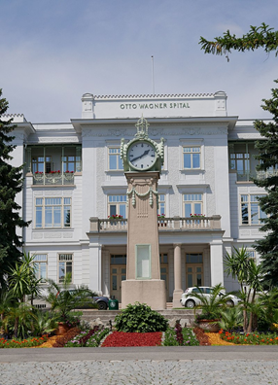

Ein Bild, das Gebäude, Himmel, Uhr, draußen enthält.

____________________________ _______________________________________

Source: <https://commons.wikimedia.org/wiki/File:Otto-Wagner-Spital_Baumgartner_H%C3%B6he_11.jpg>

**Task 3: Telling the Time**

What is the time on the clocks and watches below?

Write the time in numbers, then write it out in whatever language(s) you wish.

Ein Bild, das Uhr, Wecker, Wanduhr, Quarzuhr enthält.
[1] Ein Bild, das Uhr, Im Haus, Radiouhr, Digitale Uhr enthält.
[2] Ein Bild, das Uhr, Wanduhr, Quarzuhr, Kreis enthält.
[3]

1. ____________________ 2. ____________________ 3. ___________________

**Task 4: Saying the Time in Many Ways**

In how many ways can you say the time that you see here? For example, in Turkish, Bosnian, and German. You can also use Austrian dialect (e.g., "drei viertel neun"). 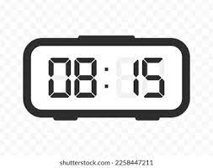 [4]

**Task 5: Clockwise**

Which direction is "clockwise"? Welche Richtung ist im Uhrzeigersinn? Where does this word come from? Why do we use it for the way clocks move?

 

**Task 6: Counting and Telling Time in Different Languages**

1. Think about **how you count** in different languages.
   * How do you say the numbers 1 to 10 in the languages you know?
2. **Telling the time**:
   * In which language do you feel most comfortable telling the time?

______________________________________________________________________

Worksheet 2: An empty clock

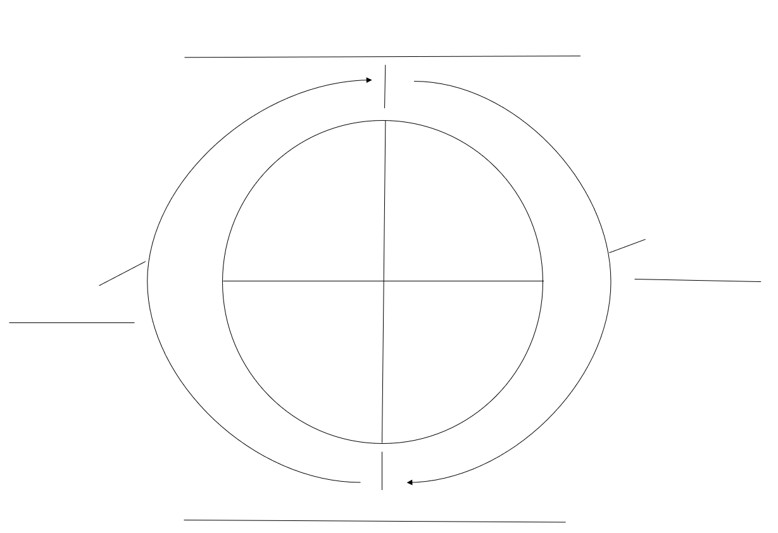



Worksheet 3: Zeynab’s Schedule

Student A

Ask questions to Student B to complete the missing activities in Zeynab’s timetable.

**Example:**

**Student A:** Does Zeynab usually read at 9:30 (half past nine) on Monday?

**Student B:** Yes, she does. / No, she doesn’t.

The missing activities:

**Dancing, Cooking, Painting, Reading, Singing, Football, Cleaning**

Each missing activity appears twice in the timetable.

|  |  |  |  |  |  |
| --- | --- | --- | --- | --- | --- |
| Time | Monday | Tuesday | Wednesday | Thursday | Friday |
| 08:30 – 09:25 | Swimming | Shopping | Park |  | Cinema |
| 09:30 – 10:25 |  | Skateboarding |  |  |  |
| 10:25 – 10:40 | **Break** | **Break** | **Break** | **Break** | **Break** |
| 10:40 – 11.35 |  |  | Shopping | Homework | Homework |
| 11:35 – 12:30 | Park |  | Skateboarding | Shopping |  |
| 12:30 – 13:30 | **Lunch** | **Lunch** | **Lunch** | **Lunch** | **Lunch** |
| 13:30 – 14:25 |  |  | Swimming |  |  |
| 14:30 – 15:25 | Bowling | Cinema |  | Bowling | Wwimming |

Follow-up Activity: Writing

Write 3 sentences about Zeynab’s day. When does Zeynab go swimming? When does she play football? When does she do her homework?

Zeynab’s Schedule

Student B

Ask questions to Student A to complete the missing activities in Zeynab’s timetable.

**Example:**

**Student B:** Does Zeynab usually swim at 8:30 (half past eight) on Monday?

**Student A:** Yes, she does. / No, she doesn’t.

The missing activities:

**Cinema, Swimming, Bowling, Shopping, Park, Skateboarding, Homework**

Each missing activity appears twice in the timetable.

|  |  |  |  |  |  |
| --- | --- | --- | --- | --- | --- |
| **Time** | **Monday** | **Tuesday** | **Wednesday** | **Thursday** | **Friday** |
| **08:30 – 09:25** |  |  |  | Cleaning |  |
| **09:30 – 10:25** | Reading |  | Dancing | Painting | Painting |
| **10:25 – 10:40** | **Break** | **Break** | **Break** | **Break** | **Break** |
| **10:40 – 11.35** | Singing | Singing |  |  |  |
| **11:35 – 12:30** |  | Football |  |  | Reading |
| **12:30 – 13:30** | **Lunch** | **Lunch** | **Lunch** | **Lunch** | **Lunch** |
| **13:30 – 14:25** | Dancing | Cooking |  | Cooking | Football |
| **14:30 – 15:25** |  |  | Cleaning |  |  |

**Follow-up Activity: Writing**

Write 3 sentences about Zeynab’s day. When does Zeynab go singing? When does she go dancing? When does she cook?

Worksheet 4: Describing Your Daily Routine[5]

**Describe your daily routine!** (You can do this in whatever languages you prefer)

**Name:**

|  |  |
| --- | --- |
|  | **My day** |
| at 7 a.m. |  |
| at 8 a.m. |  |
| at noon |  |
| in the afternoon |  |
| at 9 p.m. |  |

**Now describe your friend’s day!** (You can do this in whatever languages you prefer)

**Name:**

|  |  |
| --- | --- |
|  | **My friend’s day** |
| at 7 a.m. |  |
| at 8 a.m. |  |
| at noon |  |
| in the afternoon |  |
| at 9 p.m. |  |
|  |  |

**Write a text in English about your friend’s daily routine!**

Useful phrases:

* My friend … at seven a.m.
* Then he/she … at eight a.m.
* At noon my friend …
* After that, he/she …

**Example text:**

My friend Teila has breakfast at 7 a.m. Then she goes to school at half past seven. Her school day starts at 8 a.m. At noon Teila has lunch with her friends, and in the afternoon, she goes to the park to play with her friends. At 7 p.m. Teila showers and has dinner. Around 9 p.m. she goes to sleep because tomorrow is another school day.

Worksheet 5: Digital Resources

Try the different activities for telling the time in English. In the first column, record how many you got right the first time. If you don’t get them all correct, then try them again. Write down how many you get correct the second time. You have 15 minutes.

|  |  |  |
| --- | --- | --- |
| **Game** | **# Correct**  **1st time** | **# Correct**  **2nd time** |
| Match the time  Ein Bild, das Muster, Pixel, nähen enthält.  Automatisch generierte Beschreibung<https://wordwall.net/resource/30569161/maths/match-the-correct-time> |  |  |
| Telling the time:  Ein Bild, das Muster, Quadrat, Pixel enthält.  Automatisch generierte Beschreibung  <https://wordwall.net/resource/298935/telling-the-time-e2> |  |  |
| Telling the time (E2)  Ein Bild, das Muster, Quadrat, Pixel enthält.  Automatisch generierte Beschreibung  <https://wordwall.net/resource/298935/telling-the-time-e2> |  |  |
| Telling time:  Ein Bild, das Muster, Quadrat, Pixel enthält.  Automatisch generierte Beschreibung  <https://wordwall.net/resource/32021595/telling-time> |  |  |
| Match the clock  <https://wordwall.net/resource/33156873/maths/match-the-clocks> |  |  |
| Die Uhr lernen Apps  <https://www.otto.de/updated/ratgeber/uhr-lernen-mit-diesen-5-apps-fuer-kinder-klappts-63377/> |  |  |

1. https://commons.wikimedia.org/wiki/File:RelojDespertador.jpg
2. https://commons.wikimedia.org/wiki/File:Digital-clock-radio-basic.jpg
3. https://commons.wikimedia.org/wiki/File:Clock_11-12.svg
4. https://www.shutterstock.com/image-vector/vector-illustration-quarter-past-thirteen-digital-2258447201
5. (from Erling, Yildiz & Weidl, 2023)